**Assignment 4**

Web Analytics ISGB/BYGB 7978

Name: Minxia Ji ID: A14858975

**Question 1**

Top 3 metrics and justifications:

**Total Volume of Booking**: It perhaps is the most straightforward way to measure how successful the campaign is. A High total volume of booking means Air France has significantly improved the sales performance through a given advertising source.

**ROA**: ROA is the amount of revenue receives for every dollar spent on an advertising source. It is also a straightforward way to measure the return given a advertising source. ROA also measures how effective a given advertising source is. Therefore, the higher ROA is, the more successful the campaign is.

**Probability of Booking**: It measures the probability of generating a booking for each impression. It is also a good indicator for measuring the effectiveness of a given advertising source. The higher the probability is, the better the advertising performs.

**Question 2**

|  |  |
| --- | --- |
| volume | |
| According to the pie chart above, we know that **Grand Total** contribute **the most** booking volume for Air France, almost 50% of total booking volume from advertising sources, while **MSN-Global** contribute **the least**. The performance in terms of total booking volume from high to low is: Grand Total, Google-US, Google-Global, Yahoo-US, Overture-Global, Overture-US, MSN-US and MSN-Global. | |
| roa | |
| The histogram is plotted according to the descending order of ROA. The rank from high ROA to low ROA is the x axis labels from left to right. **Yahoo-US** performs **best** on ROA indicator while **Overture-US** performs the **worst**. ROA of Yahoo-US is signigicantly higher than that of other publishers and it is almost two times of the second highest. | |
| pob | |
| The histogram is plotted according to the descending order of probability of booking. The rank from high POB to low POB is the x axis labels from left to right. **MSN-Global** did a good job to generate a booking from a impression while **Overture-US** did the **worst**. | |
| bubble | bubble2 |
| X axis is total volume of bookings, y axis is ROA and the size of bubbles represent the probability of booking. Therefore, the **ideal publisher** should be on the **top right corner with a larger size** **bubble**. The Grand-Total contribute the most volume of bookings in total volume of bookings, but it perfoms not good on ROA, thus it is not the ideal publisher. Because of the large volume of bookings of Grand Total enlarge the scale of x axis, it is too large to differentiate other publishers. Then we can delete Grand Total, the **most ideal publisher** is obvious: it is **Yahoo-US** in blue bubble, which has high total volume of bookings, high ROA and high probability of booking. | |

**Question 3**

**Illustrated 3 metrics affect each other:**

Probability of Booking = CTR * TCR.

CTR = Probability of Booking/TCR.

Probability is positively related with CTR and TCR. An increase in CTR or TCR will lead to an increase in probability of booking proportionally on average.

CTR is positively related with Probability of booking while is negatively related with TCR. An increase in Probability of booking will lead to an increase in CTR, while an increase in TCR will lead to a decrease in CTR.

**With low CTR campaigns**: low CTR means the ad is not helpful or not relevant to customers. The media contacts should try to improve the search precission.

**With low TCR campaigns**: low TCR means the ability of generating a booking from per click is limited. The media contacts should try to improve the contend and design of the website which leads to transactions.

**Question 4**

**list the top 10 campaigns (keyword groups) and the bottom 10 campaigns**

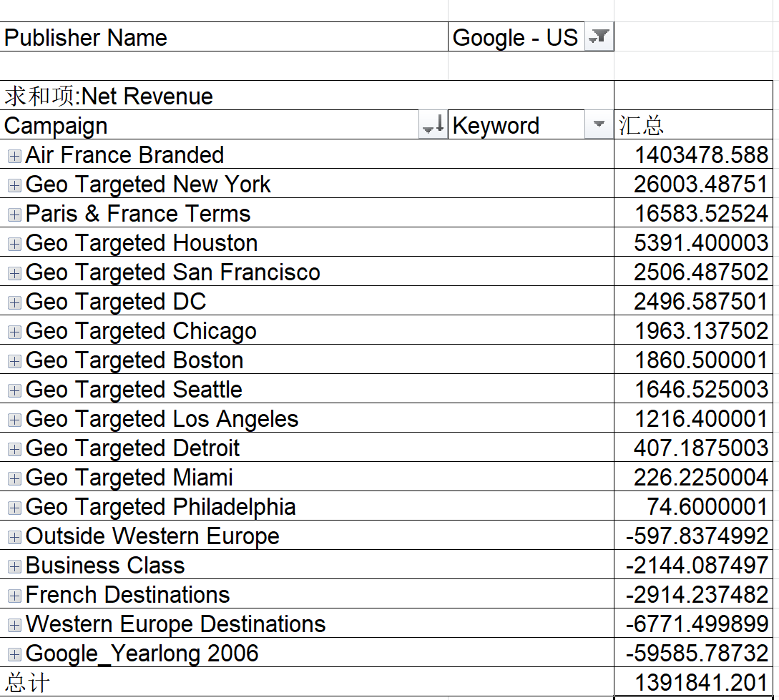

Top 10: Air France Branded, Geo Targeted New York, Paris&France Terms, Geo Targeted Huston, Geo Targeted San Francisco, Geo Targeted DC, Geo Targeted Chicago, Geo Targeted Boston, Geo Targeted Seattle, Geo Targeted Los Angeles.

Bottom 10: Geo Targeted Seattle, Geo Targeted Los Angeles, Geo Targeted Detroit, Geo Targeted Miami, Geo Targeted Philadelphia, Outside Western Europe, Business Class, Frech Destinations, Western Europe Destinations, Google_Yearlong 2006.

**Based on the analysis of these campaigns and keywords included in each campaign, what suggestion will you provide?**

|  |  |
| --- | --- |
| 11 | 22 |

According to the **left plot above**, keywords performed worst also appear in bottom campaigns. I picked the **worst** 10 keywords in terms of net revenue and most of them are **too general** keyword such as ‘flight’, ‘cheap’ and ‘france travel’. General keywords are very expensive yet competitive because a lot of companies will bid on that. Even sometimes these keywords might lead to more clicks even bookings, the cost is too high to make high net revenue. Also, we noticed that even some specific keywords with geo location like ‘turkey’ in them performed **not well**. That might because these locations are **not popular**.

According to the **right plot above**, keywords performed best also appear in top campaigns. I picked the **best** 10 kewords in terms of net revenue and most of them are very **specific** and pointed to ‘airfrance’ itself. That makes sense because people who are searching keywords about Air France are more likely to book a flight with Air France thus yield high net revenue. It is very interesting to notice that ‘flight to paris’ also **performed well**, which might because that Paris is a **attractive location** to customers.

**Suggestion**: For the campaigns on the publisher Google-US, Air France should **decrease** the expenses on general keywords and keywords with unpopular locations; Air France should **increase** the expenses on more specific keywords such as keywords with ‘airfrance’ or popular geo location such as ‘Paris’.

**Question 5**

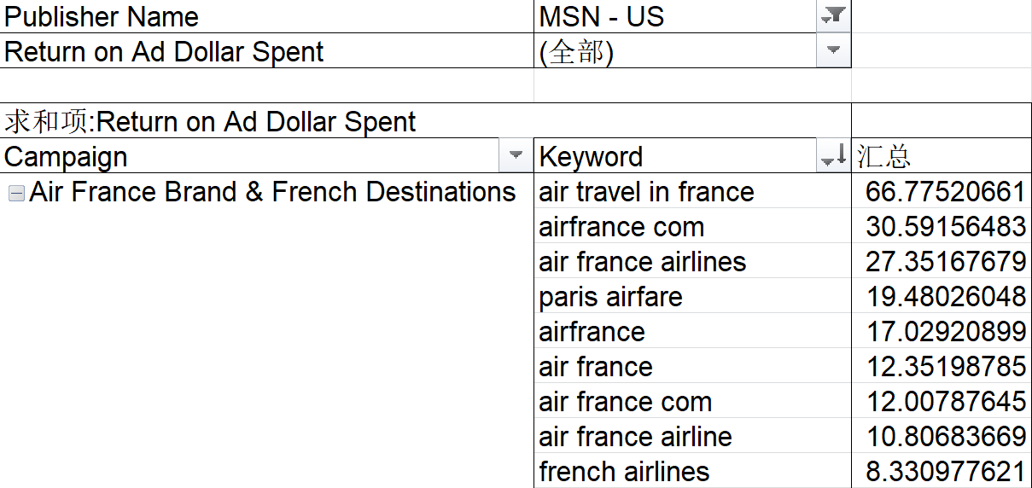

Based on the highest ROA ranking, we can conclude that for the publisher MSN-US, the campaign, ‘Air France Brand&French Destinations’ generates the highest ROA.

**Question 6**

Focusing on the keyword performance, **how specific and how relevant** a keyword is could affect the average position of a keyword.

**Example: MSN-Global in terms of ROA.**

|  |  |
| --- | --- |
| 61 | 62 |

In campaign keywords of the publisher, MSN-Global, based on the indicator ROA, we observed that keywords performed very well on the left plot above. The very specific keywords, ‘air discount france ticket’ generated a astonishing high ROA and other specific/with high relevance with Air France keywords also performed well. However, the keywords which are more general performed bad. Also, the keyword with lower relavance to Air France(such as ‘aeroport lyon’ ) performed not well.

**Question 7**

Recommendations:

1. For search engines with **high probability of booking and low CPC**, such as MSN-Global and Yahoo-US, which are efficient at generating bookings and cheaper. Air France should definately invest more on these publishers with appropriate campaign strategies.
2. For search engines with **low probability of booking and low CTR**, such as Overture, which means they are not good at generating bookings and also not targeted customers well. Air France should reduce the advertising fees on them even not to advertise through them. However, the CPC for Overture is relatively lower than that of other search engines, thus Air France can consider modify campaign strategies on Overture rather than abandon it arbitrarily.
3. For search engines **with high probability of booking and high CPC**, such as Google and MSN-US, which means they are expensive but they are efficient. Air France should optimize the campaign strategies to reduce the cost as much as possible.